mvn clean package
java -jar target/hello-world-crud-1.0.jar
docker build -t hello-world-crud .
docker run hello-world-crud
git init
git add .
git commit -m "Initial commit"
git remote add origin https://github.com/your-username/hello-world-crud.git
git branch -M main
git push -u origin main
kubectl apply -f deployment.yaml
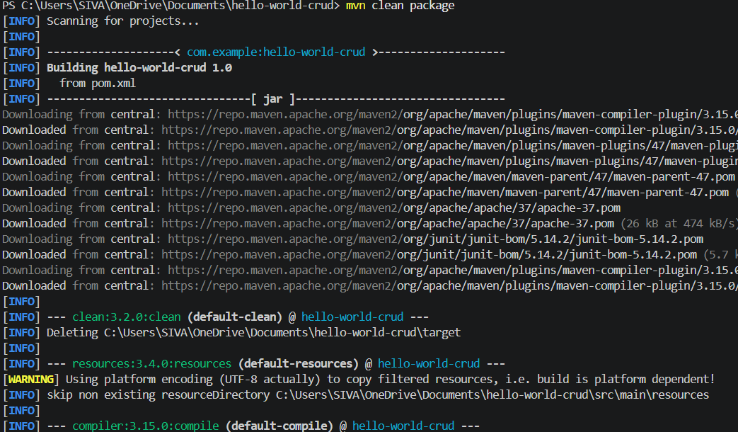
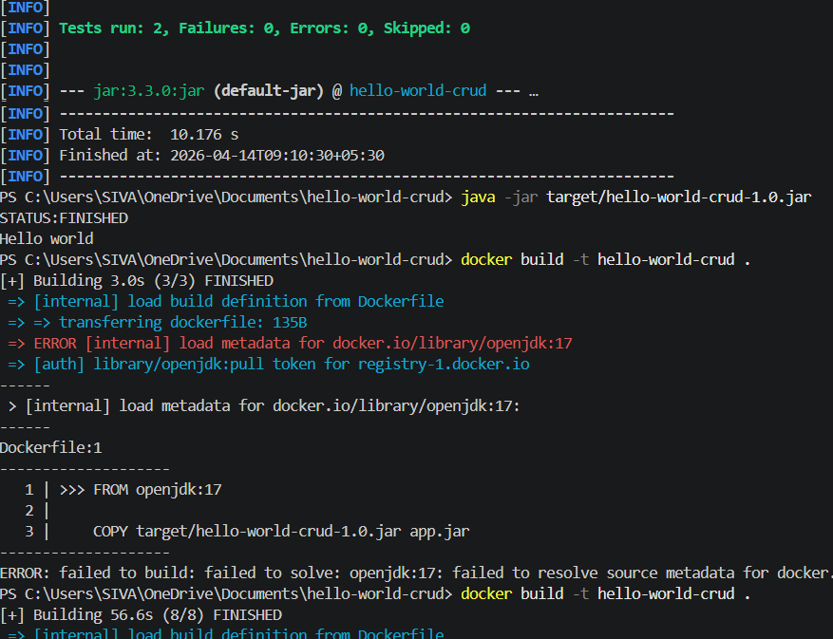
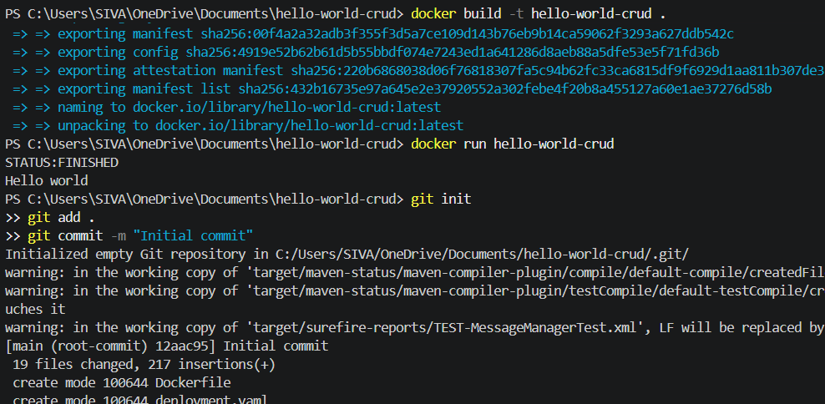
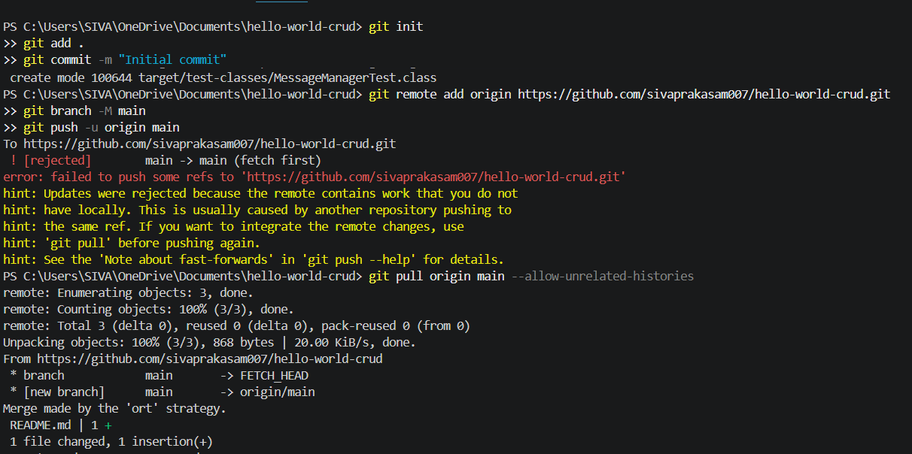
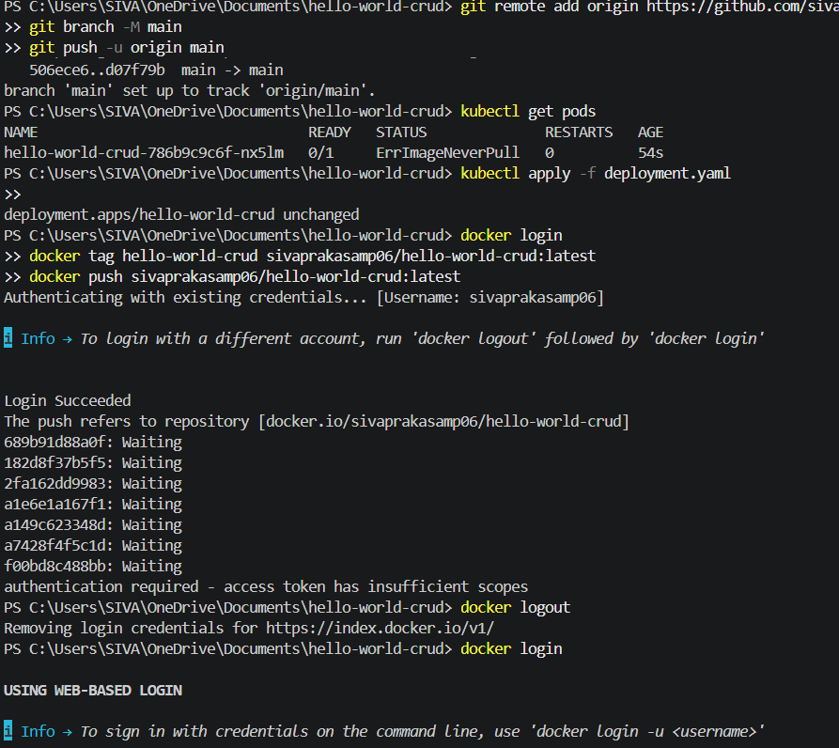
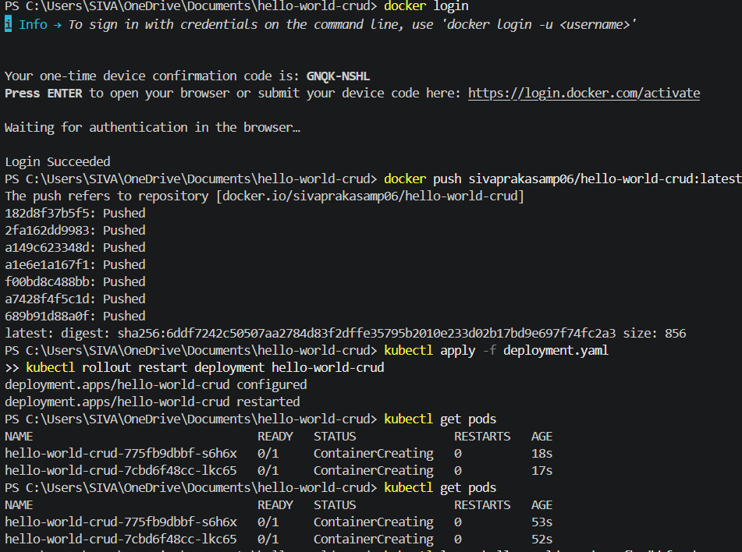
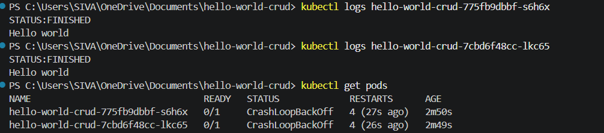
dckr_pat_AbyUfOgsHU-iUFq0r04VrpY-50k
docker logout
docker login -u sivaprakasamp06

